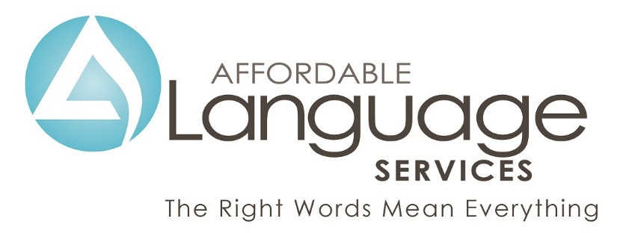

“One Moment Please” Tool

How to Say “One Moment Please” in Eighteen Common Languages
